**DSA Assignment – 2nd July**

**Name – Karan Joshi**

**Roll No. – 23/11/EC/036**

**Leetcode Id – Karan_Joshi068048**

**Geeksforgeeks Id – wwwjoshikaran3424**

**Github Repo Link -** [**https://github.com/KaranJoshi101/urban-octo-robot/**](https://github.com/KaranJoshi101/urban-octo-robot/)

DSA-Section -

Question 1: Design Stack Using Queues

Platform: LeetCode

Problem Link: <https://leetcode.com/problems/implement-stack-using-queues/description/>

Submission Screenshot:

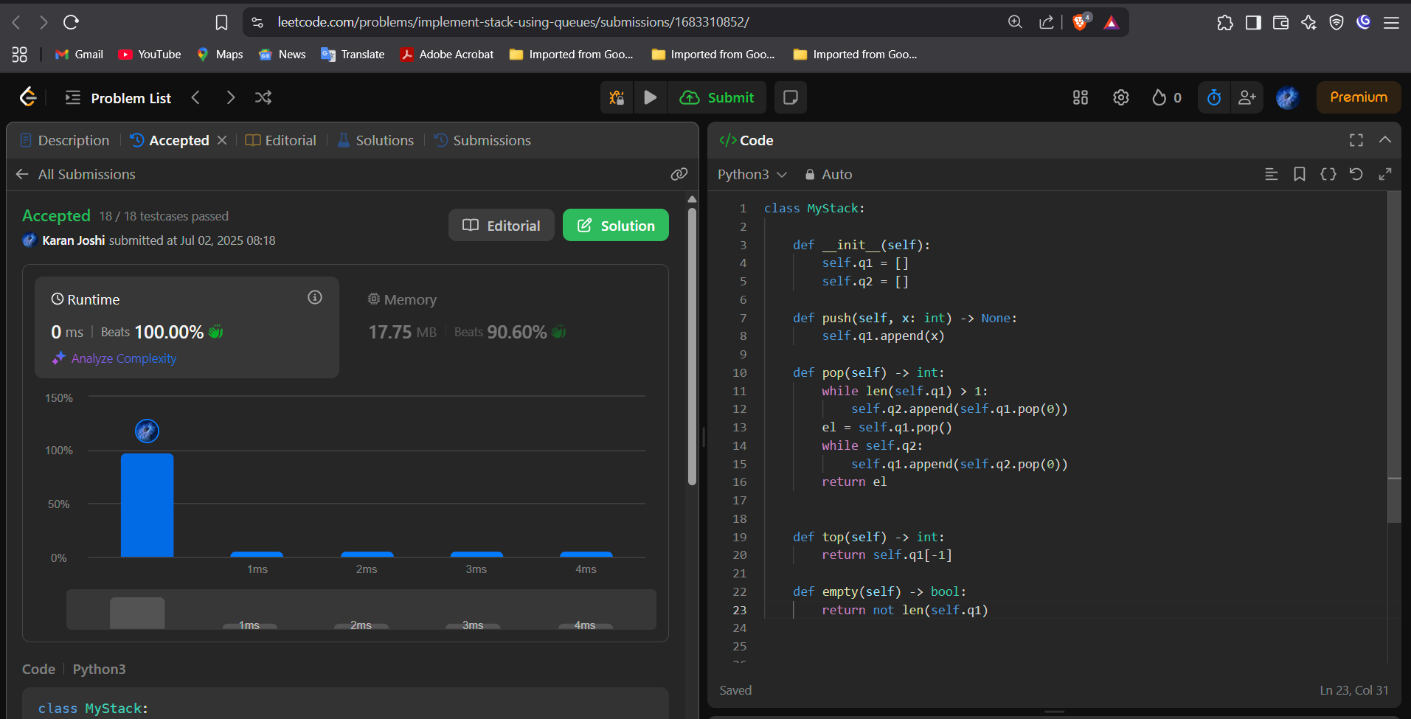

Question 2: Design Queues Using Stack

Platform: LeetCode

Problem Link: <https://leetcode.com/problems/implement-queue-using-stacks/description/>

Submission Screenshot:

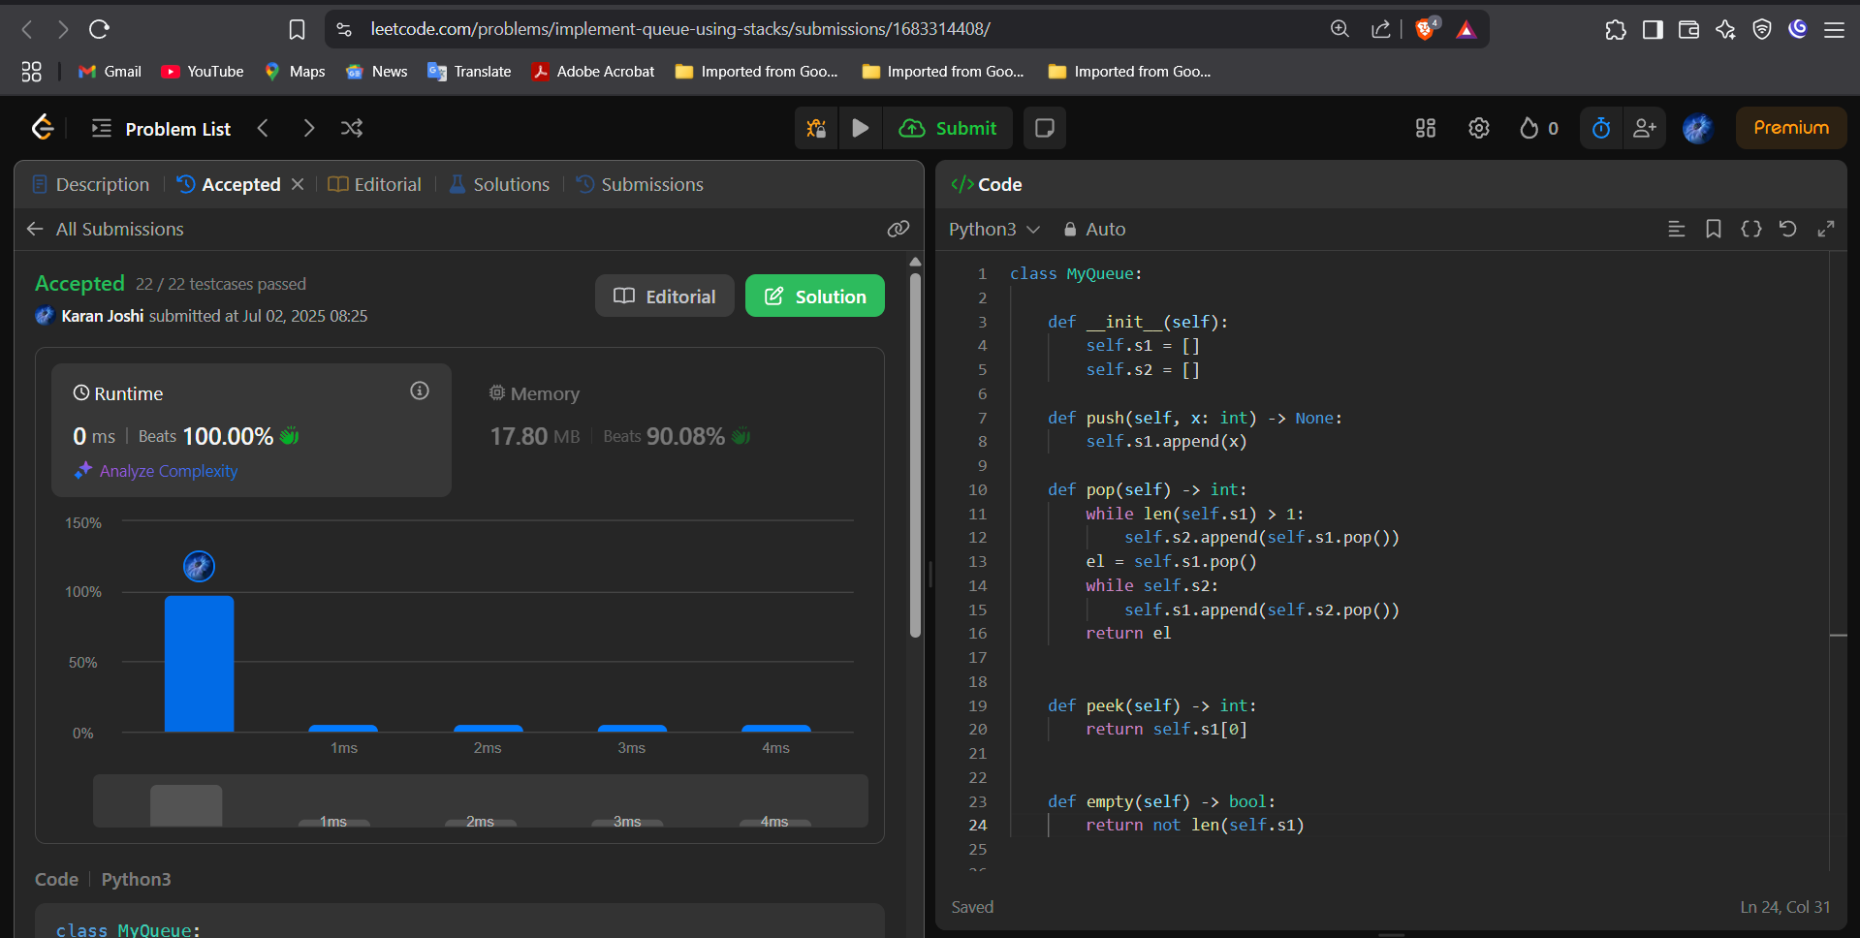

Question 3: Evaluate Reverse Polish Notation

Platform: LeetCode

Problem Link: <https://leetcode.com/problems/evaluate-reverse-polish-notation>

Submission Screenshot:

